**Comparison of two methods of creating the zip code-level NEVI:**

* **Method #1 (main):** Calculating from the tract-level **overall NEVI + subdomain scores**:
  + Keep: Only NYC zip codes
    - Corresponding to ZCTAs from NYC DOHMH: <https://data.cityofnewyork.us/Health/Modified-Zip-Code-Tabulation-Areas-MODZCTA-/pri4-ifjk>
  + Multiply: Weighted scores = (RESIDENTIAL RATIO)*(Tract-Level NEVI/NEVI subdomain scores)
  + Sum: Weighted scores by zip code
  + Divide: (Summed weighted scores)/(summed RESIDENTIAL RATIO)
    - Note: RESIDENTIAL RATIO sometimes < 1 because some zip codes was only partially within NYC)
  + Exclude: zip codes with summed RESIDENTIAL RATIO = 0
    - RESIDENTIAL RATIO = 0 occurred because a zip code was only partially in NYC—the tract inside has a ratio of 0).
* **Method #2** (sensitivity analysis)**:** Calculating from the tract-level **features**:
  + Keep: Only NYC zip codes
  + Exclude tracts:
    - Population < 20 & missing at least 1 feature
    - Same exclusion for CDC PLACES + census data (based on missing census data)
  + Exclude zip codes:
    - Where RESIDENTIAL RATIO = 0
      * in original crosswalk dataset
      * after excluding tracts (since some zip code-tract levels were removed)
  + Calculate: Weighted features = (RESIDENTIAL RATIO)*(Tract-Level features)
  + Sum: Weighted features by zip code
  + Divide: (Summed weighted features)/(summed RESIDENTIAL RATIO)
  + Calculate: NEVI from Toxpi using weighted features, and then subdomain scores from Toxpi output
* Compared zip code-level NEVI from Method #1 vs. Method #2

**Comparison Results**

2 zip codes included from Method #2 but not in Method #1 (bright blue)

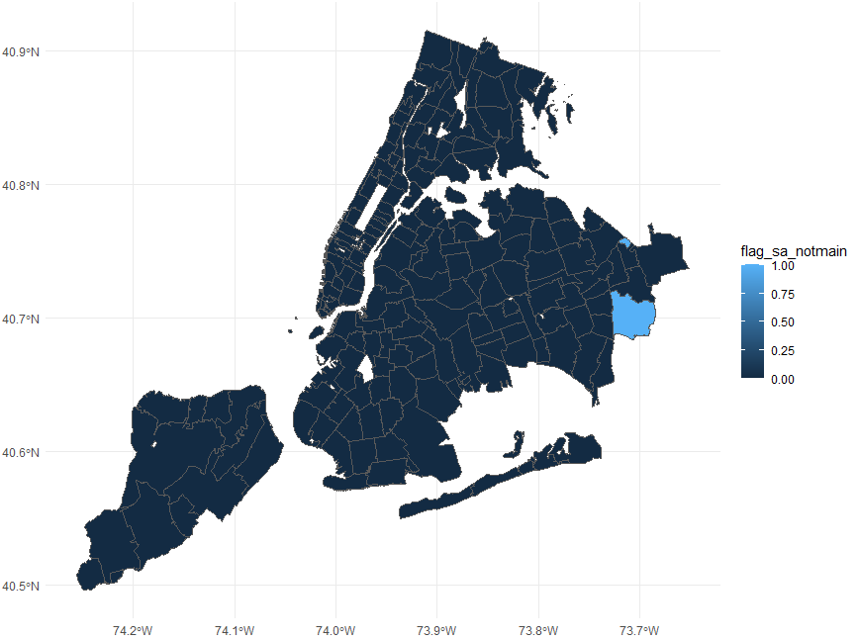

**Distributions of differences (Method #1 – Method #2)**

|  |
| --- |
| **NEVI** |

|  |  |
| --- | --- |
| **Demographics** | **Economic Indicators** |

|  |  |
| --- | --- |
| **Residential Characteristics** | **Health Status** |